Ideation Phase
Brainstorm & Idea Prioritization Template

Date | 15 October 2026
Team ID | 23891A05C2
Project Name | Medical Diagnosis Center
Maximum Marks | 4 Marks

Brainstorm & Idea Prioritization Template:
Brainstorming provides a free and open environment that encourages everyone within a team to participate in the creative thinking process that leads to problem solving.
Prioritizing volume over value, out-of-the-box ideas are welcome and built upon, and all participants are encouraged to collaborate, helping each other develop a rich amount of creative solutions.
Use this template in your own brainstorming sessions so your team can unleash their imagination and start shaping concepts even if you're not sitting in the same room.

Step-1: Team Gathering, Collaboration and Select the Problem Statement
Selected Problem Statement
Manual and disconnected diagnostic-center processes make test booking, appointment scheduling, patient communication, report tracking, and record management difficult. The project proposes a centralized ServiceNow application and Service Portal to streamline these activities.

Team / Stakeholder Contributions
- Patients: Book tests, view appointments, receive notifications, and download reports.
- Receptionists / Staff: Maintain booking details, manage patient records, and coordinate appointments.
- Lab Technicians: Update sample collection and processing stages and coordinate test availability.
- Lab Manager / Administrators: Manage test approvals, monitor dashboards, and handle escalations.
- ServiceNow Administrator / Developer: Configure tables, forms, portal pages, workflows, access controls, and notifications.

Guiding Principles
  - Provide a simple patient experience.
  - Prevent overlapping appointments.
  - Protect medical information using role-based access.
  - Track report status from sample collection to report availability.

  - Use dashboards to improve operational decisions.

Step-2: Brainstorm, Idea Listing and Grouping
The ideas from the project are grouped by the operational need they address.
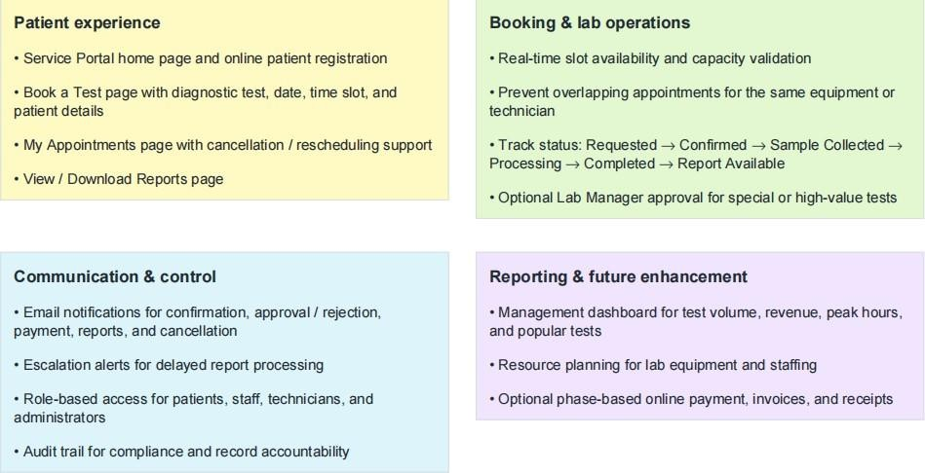
Step-3: Idea Prioritization
Ideas are prioritized by importance to the project and feasibility based on the proposed ServiceNow implementation. The matrix is a planning
aid; online payment is marked as phase-based in the project.
